docker node ls

docker node promote node

docker node demote node

docker swarm leave

docker swarm leave --force

docker service rm nginxtest

docker service ps

docker service ps --format 'table'

docker service create --name nginx --replicas 3 nginx

1. Create Swarm Cluster & Swarm basic commands. RAFT DB.

2. Understand overlay driver & Create overlay network.

<https://docs.docker.com/v17.09/engine/swarm/networking/#firewall-considerations>

3. Understand services and Create a service.

4. Updating & Scaling Swarm service.

5. Routing Mesh Swarm visualizer.

<https://github.com/dockersamples/docker-swarm-visualizer>

docker run -it -d -p 8080:8080 -v /var/run/docker.sock:/var/run/docker.sock

dockersamples/visualizer

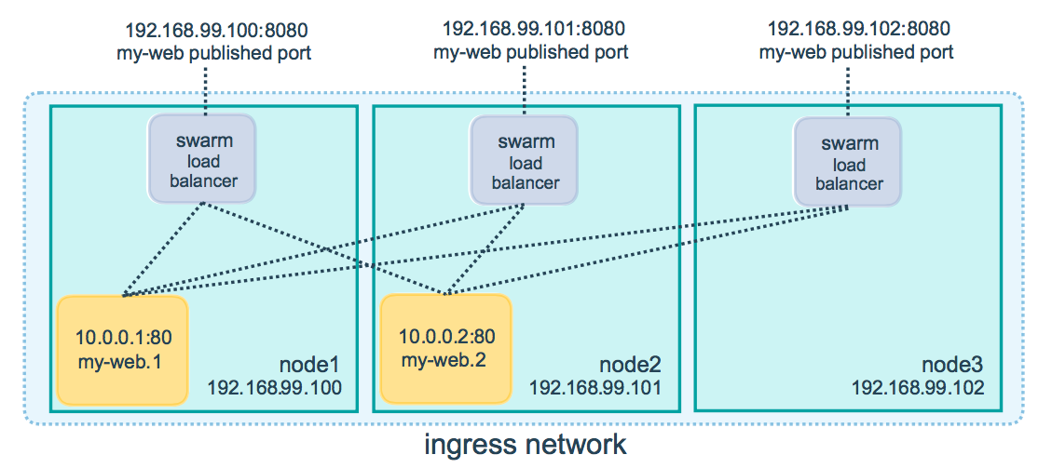

6. Container Placement.

* Service Constraint:
* docker service create --constraint=node.role==manager nginx
* docker service create --constraint=node.role!=worker nginx
* node.<label>=custom label
* node.role=inbuult label
* docker node update --label-add=dmz=true node2
* docker service create --constraint=node.labels.dmz==true nginx

7. Swarm Rolling Updates.

docker service create \

--replicas 3 \

--public 8000:80 \

--name nginx \

--update-parallelism 1 \

--update-delay 10s \

sreeharshav/rollingupdate:v1

docker service inspect --pretty nginx

docker service update --image sreeharshav/rollingupdate:v3 nginx

docker service inspect --pretty nginx

docker service update nginx

docker service ps nginx

docker run -it -d -p 8080:8080 -v /var/run/docker.sock:/var/run/docker.sock dockersamples/visualizer

Default Labels:

docker node update --label-add mgmt=yes node1

docker node update --label-rm mgmt node1

docker node update --label-add PRODUCTION node5

docker node update --label-rm PRODUCTION node5

docker node update --label-add dev=yes node4

docker node update --label-add dev=yes node5

docker service create --name prodtest --constraint node.labels.prod==yes --replicas 2 sreeharshav/rollingupdate:v3

docker service create --name ptest --constraint node.labels.dev==yes --replicas 4 sreeharshav/rollingupdate:v3

OR

docker node update --label-add ssd=yes node2

docker node update --label-add ssd=yes node3

docker node update --label-add hdd=yes node4

docker node update --label-add hdd=yes node5

docker service create --name SSD-APP --constraint node.labels.ssd==yes --publish 9000:80 --replicas 6 sreeharshav/rollingupdate:v1

docker service create --name HDD-APP --constraint node.labels.hdd==yes --publish 6000:80 --replicas 6 sreeharshav/rollingupdate:v1

docker service create --name HDD-APP --constraint node.labels.hdd==yes --publish 6000:80 --replicas 6 sreeharshav/rollingupdate:v1

docker service create --name TESTING1 --constraint=node.role==manager -p 5000:80 --replicas 3 nginx

docker service create --name TESTING2 -p 5000:80 --constraint=node.role!=manager --replicas 4 sreeharshav/rollingupdate:v3

docker node update --label-add dev=true node2

docker node update --label-add dev=true node3

docker node update --label-add prod=true node4

docker node update --label-add prod=true node5

docker service create --name DEVNGINX --publish 7000:80 --constraint=node.labels.dev==true --replicas 4 nginx

docker service create --name PRODNGINX --publish 5000:80 --constraint=node.labels.prod==true --replicas 4 nginx

**Docker Stack Deploy:**

<https://github.com/dockersamples/example-voting-app>

**Docker Traefik Steps:**

<https://blog.programster.org/using-traefik-with-docker-swarm-for-deploying-web-applications>

**DNS Records alias to NLB:**

web1.sreetrainings.xyz

web2.sreetrainings.xyz

web3.sreetrainings.xyz

**Traefik Service Creation:**

docker service create \

--name traefik \

--constraint=node.role==manager \

--publish 80:80 \

--publish 8080:8080 \

--mount type=bind,source=/var/run/docker.sock,target=/var/run/docker.sock \

--network traefik-net \

traefik:v1.6 \

--docker \

--docker.swarmmode \

--docker.domain=traefik \

--docker.watch \

--web

docker service create \

--name webapp1 \

--label traefik.port=80 \

--network traefik-net \

--label traefik.frontend.rule=Host:web1.sreetrainings.xyz\

sreeharshav/rollingupdate:v1

docker service create \

--name webapp2 \

--label traefik.port=80 \

--network traefik-net \

--label traefik.frontend.rule=Host:web2.sreetrainings.xyz\

sreeharshav/rollingupdate:v2

docker service create \

--name webapp3 \

--label traefik.port=80 \

--network traefik-net \

--label traefik.frontend.rule=Host:web3.sreetrainings.xyz\

sreeharshav/rollingupdate:v3

NODE AVAILABILITY:

================

docker node update --availability pause node5 - Dont accept new tasks , runs existing.

docker node update --availability active node5

docker node update --availability drain node5 - Reschedule talsks

Resource Requirements:

====================

Limits: max

Reservations: min

docker service create --reserve-memory 800M --reserve-cpu 1 --name MEMCPUTEST1 --replicas 3 --publish 4000:80 sreeharshav/rollingupdate:v3

docker service create --name LIMITTEST --limit-cpu .25 --limit-memory 100M --replicas 3 --publish 3000:80 sreeharshav/rollingupdate:v3

docker service update LIMITTEST --limit-memory 10M --limit-cpu .10

docker service update LIMITTEST --limit-memory 0 --limit-cpu 0

docker service rm DEVNGINX LIMITTEST MEMCPUTEST1 PRODNGINX

docker service create --name CPULARGE2 --reserve-cpu 80 sreeharshav/rollingupdate:v3

STRESS Dockerfile:

================

FROM debian:latest

RUN apt-get update && apt-get install -y stress \

--no-install-recommends && rm -r /var/lib/apt/lists/*

CMD ["stress", "--verbose", "--vm", "1", "--vm-bytes", "256M"]

Container Healthchecks:

====================

Docker container healthchecks

<https://blog.sixeyed.com/docker-healthchecks-why-not-to-use-curl-or-iwr/>

HEALTHCHECK CMD curl --fail http://localhost:3000/ || exit 1

docker inspect --format='{{json .State.Health}}' your-container-name

docker service logs NGINX

docker service logs wza88dx6v4pr

docker service logs wza88dx6v4pr --no-task-ids

docker service logs --raw --no-trunc wza88dx6v4pr

docker service logs --raw --no-task-ids --no-trunc wza88dx6v4pr

docker service logs --tail 10 --follow --raw --no-trunc NGINX

==========================================================================

https://docs.docker.com/engine/reference/commandline/events/

=====================================================================

**DOCKER CONFIG:**

docker config create nginxindex1 index.html

docker service create --name nginx1 --config src=nginxindex1 ,target=/usr/share/nginx/html/index.html --publish 8000:80 sreeharshav/rollingupdate:v3

docker service update --config-rm config1 --config-add src=config2,target=/usr/share/nginx/html/index.html nginx1

Docker Swarm Secrets:

===================

<https://blog.ruanbekker.com/blog/2017/11/23/use-docker-secrets-with-mysql-on-docker-swarm/>

Jenkins Docker Swarm Deploy:

=========================

nano /lib/systemd/system/docker.service

ExecStart=/usr/bin/dockerd -H unix:// -H tcp://0.0.0.0:2375

systemctl daemon-reload

systemctl restart docker

sudo nohup docker daemon -H tcp://0.0.0.0:2375 -H unix:///var/run/docker.sock &

sudo usermod -a -G root jenkins

usermod -a -G docker jenkins

<http://www.littlebigextra.com/automate-service-deployment-docker-swarm-using-jenkins/>

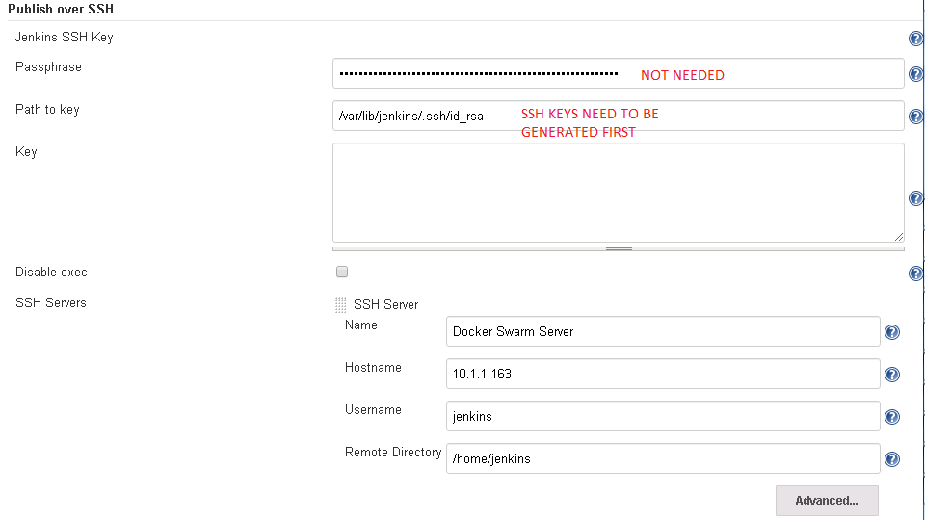

Give /swarm/ in the remote directory.

OLD-PIC:

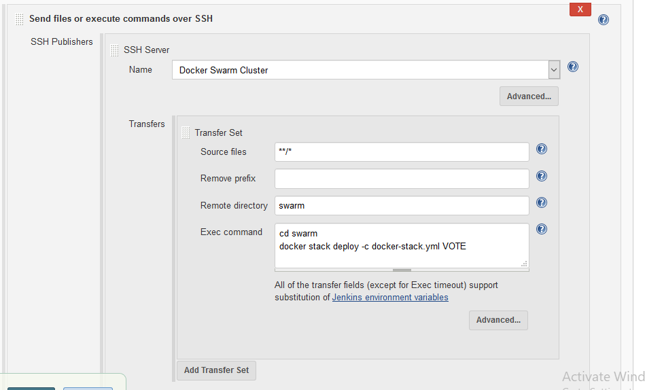

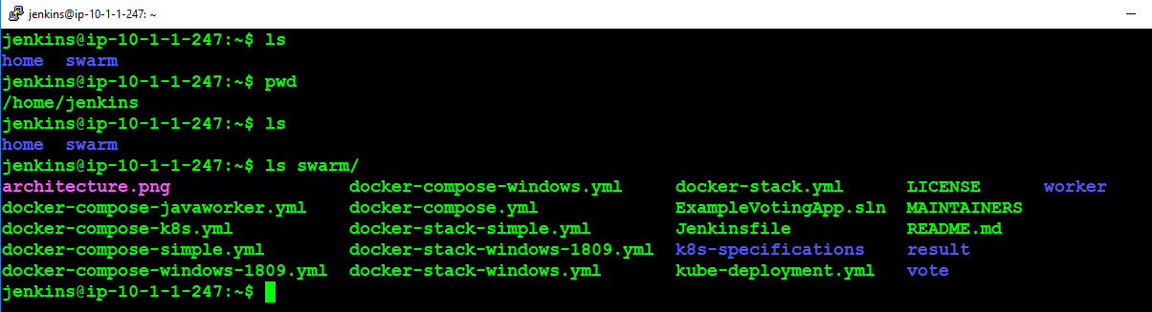

NEW-PIC:

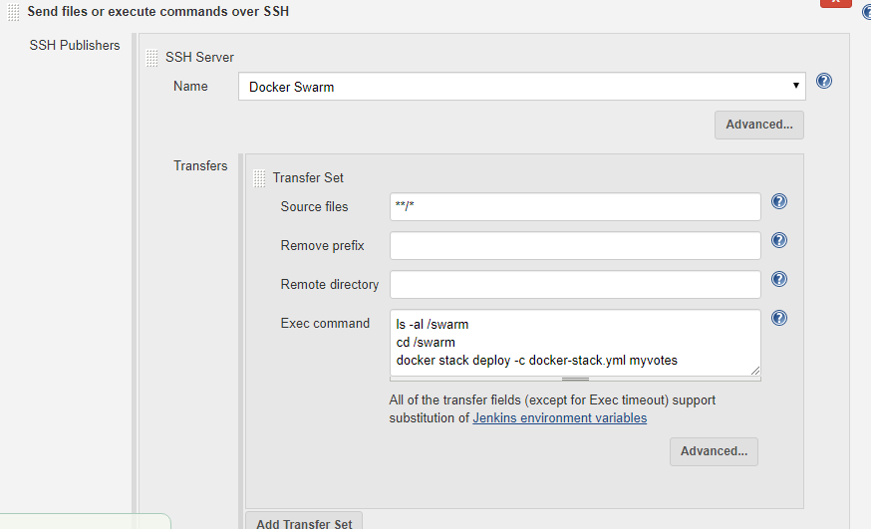

<https://linuxize.com/post/how-to-install-jenkins-on-ubuntu-18-04/>

nano /lib/systemd/system/docker.service

ExecStart=/usr/bin/dockerd -H unix:// -H tcp://0.0.0.0:2375

systemctl daemon-reload

systemctl restart docker

sudo nohup docker daemon -H tcp://0.0.0.0:2375 -H unix:///var/run/docker.sock &

sudo usermod -a -G root jenkins

usermod -a -G docker jenkins